**Deploy Netflix Clone on Kubernetes**

**Phase 1 →**deploy netflix locally on ec2 (t2.large or medium)

**Phase 2 →**Implementation of security with sonarqube and trivy

**Phase 3 →**Now we automate the whole deployment using by jenkins pipeline

**Phase 4 →**Monitering via Prmotheus and grafana

**Phase 5 →** Kubernetes →

----------------------------------------------------------------------------------

**Phase 1 → deploy netflix locally on ec2 (t2.large)**

**Step 1 →setup ec2**

1. go to aws console and launch ubuntu 22.04 with t2.large and 25 gb of storage allocated with it don’t forget to enable public ip in vpc settings

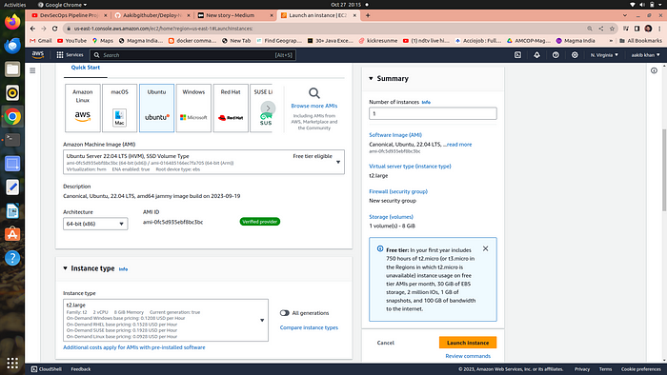

2. let’s connect to your ec2 via ssh using command “ssh -i “mykey.pem” [ubuntu@ec2–54–197–62–157.compute-1.amazonaws.com](mailto:ubuntu@ec2-54-197-62-157.compute-1.amazonaws.com)”

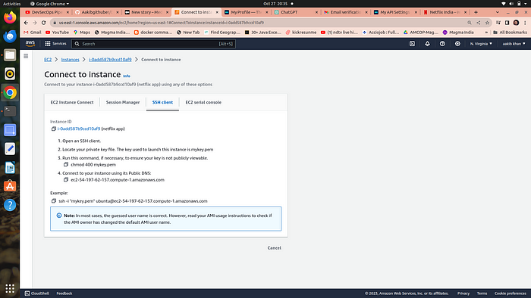

3. run the following commands

a. sudo su

b. apt update

clone the github repo by

c. git clone <https://github.com/Hussain147/netflix-cicd/>

**Make sure to create an elastic ip address to associate with your instance**

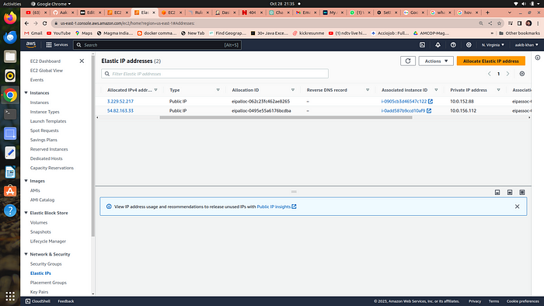

**Step 2 → setup docker and build images**

**run the following commands to install docker→**

a. **apt-get install docker.io**  
b. **usermod -aG docker $USER** # Replace with your username e.g ‘ubuntu’  
c. **newgrp docker**  
d.**sudo chmod 777 /var/run/docker.sock**→ #is used to grant full read, write, and execute permissions to all users for the Docker socket file, which allows unrestricted access to the Docker daemon and is a significant security risk.

**run the following commands to build and run docker container →**

a. **docker build -t netflix .**

b. **docker run -d — name netflix -p 8081:80 netflix:latest** → this maps the container port to your ec2 port

c. **go to your ec2 →security groups →open the port 8081**by adding rule custom tcp = 8081

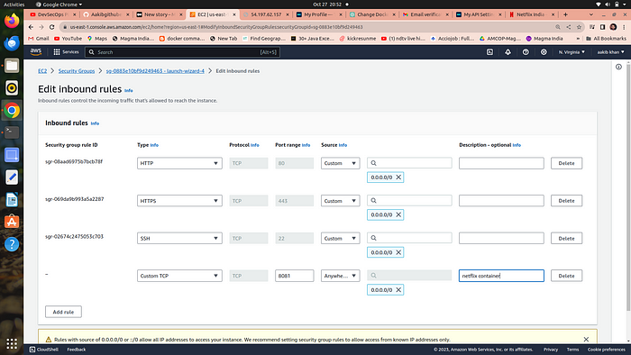

**your aplication is running go to your ec2 copy public ip and browse**[**http://your\_public\_ip:8081**](http://your_public_ip:8081/)**and it’s open like this**

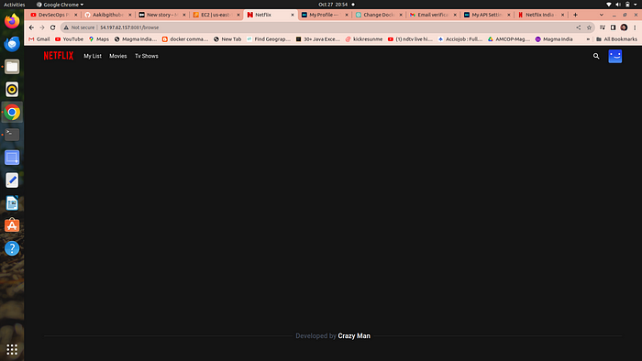

**Its shows a blank page of netflix because you don’t have a api that’s communicate with netflix database let’s solve this**

**what is an API→**

An API (Application Programming Interface) is like a menu for a restaurant that lets you order food (data or functions) from a software system or application, allowing different programs to talk to each other and share information in a structured way.

**Step 3 → setup netflix API**

* Open a web browser and navigate to TMDB (The Movie Database) website.
* Click on sign up
* Now enter your username and pass for sign in then go to your profile and select “Settings.”
* Click on “API” from the left-side panel.
* Create a new API key by clicking “generate new api key ” and accepting the terms and conditions.
* Provide the required basic details such as name and website url of netflix and click “Submit.”
* You will receive your TMDB API key.

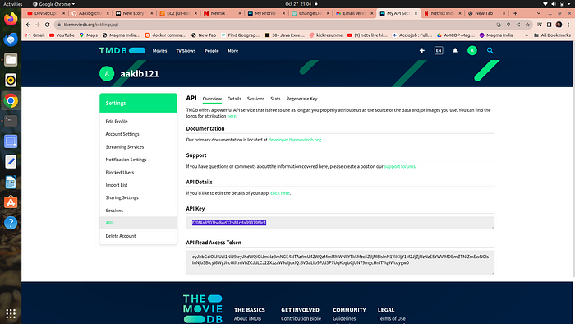

copy the api key

**Now delete the existing image by**

a. **docker stop <containerid>**  
b. **docker rmi -f netflix**

**Run the new container by follwing command**

1. docker build -t netflix:latest — build-arg TMDB\_V3\_API\_KEY=your\_api\_key .
2. docker run -d -p 8081:80 netflix

**your container is created**

**now again browse the same url you will see the whole netflix database is connected to your netflix clone app**



congrats your aplication is running

**Phase 2 → Implementation of security with sonarqube and trivy**

**what is sonarqube →**

SonarQube is like a “code quality detective” tool for software developers that scans your code to find and report issues, bugs, security vulnerabilities, and code smells to help you write better and more reliable software. It provides insights and recommendations to improve the overall quality and maintainability of your codebase

**what is trivy →**

Trivy is like a “security guard” for your software that checks for vulnerabilities in the components (like libraries) your application uses, helping you find and fix potential security problems to keep your software safe from attacks and threats. It’s a tool that scans your software for known security issues and provides information on how to address them.

**step 1 → setup sonarqube on your ec2**

run the following commands to isntall and run the conatainer of sonarqube on port no. 9000

a. **docker run -d — name sonar -p 9000:9000 sonarqube:lts-community**

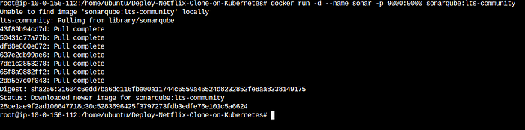

**go and open port 9000 forn sonarqube to your ec2 security group**

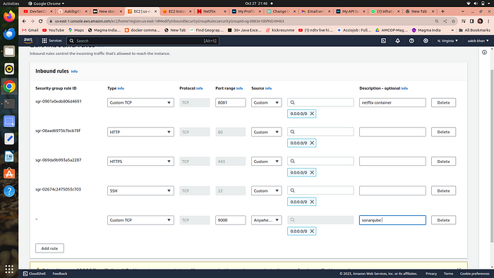

Now browse [**http://your\_public\_ip:**](http://your_public_ip:8081/)**9000**you will see **sonarqube is running**

**username =admin  
password=admin**

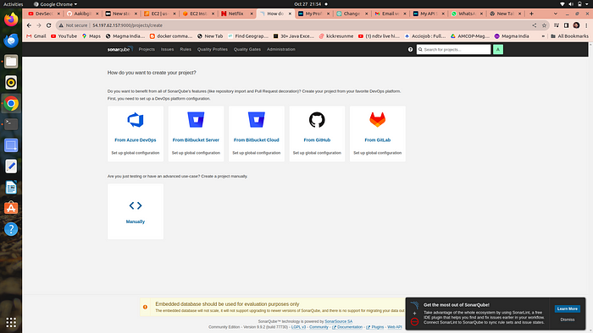

your sonarqube dashboard

**Step 2 → setup Trivy**

run the following commands

a. sudo apt-get install wget apt-transport-https gnupg lsb-release

b. wget -qO — <https://aquasecurity.github.io/trivy-repo/deb/public.key> | sudo apt-key add -

c. echo deb <https://aquasecurity.github.io/trivy-repo/deb> $(lsb\_release -sc) main | sudo tee -a /etc/apt/sources.list.d/trivy.list

d. sudo apt-get update

e. sudo apt-get install trivy

**now your trivy is ready to check and scan your image for any vulnerabilities**

**to check run the following commands**

a. trivy image <image id>

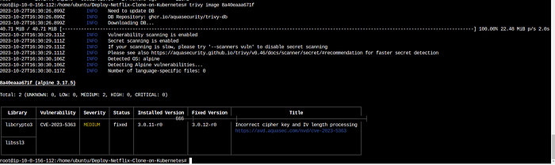

here’s the scan of your image of netflix

**Phase 3 →Now we automate the whole deployment using by jenkins pipeline**

**Step 1 →install and configure jenkins via terminal …jenkins also required java for run itself so we install java and then jenkins**

commands to run on the terminal →

**setup java**

1. sudo apt update
2. sudo apt install fontconfig openjdk-17-jre
3. java -version  
   **output →**openjdk version “17.0.8” 2023–07–18  
   OpenJDK Runtime Environment (build 17.0.8+7-Debian-1deb12u1)  
   OpenJDK 64-Bit Server VM (build 17.0.8+7-Debian-1deb12u1, mixed mode, sharing)

**Setup jenkins**

1. sudo wget -O /usr/share/keyrings/jenkins-keyring.asc \  
   <https://pkg.jenkins.io/debian-stable/jenkins.io-2023.key>
2. echo deb [signed-by=/usr/share/keyrings/jenkins-keyring.asc] \  
   <https://pkg.jenkins.io/debian-stable> binary/ | sudo tee \  
   /etc/apt/sources.list.d/jenkins.list > /dev/null
3. sudo apt-get update
4. sudo apt-get install jenkins
5. sudo systemctl start jenkins
6. sudo systemctl enable jenkins
7. Access Jenkins in a web browser using the public IP of your EC2 instance [**http://publicIp:8080**](http://publicip:8080/)

**Install some suggested plugins for pipeline to run without errors**

1 Eclipse Temurin Installer (Install without restart)

2 SonarQube Scanner (Install without restart)

3 NodeJs Plugin (Install Without restart)

4 Email Extension Plugin

6.**owasp →**The OWASP Plugin in Jenkins is like a “security assistant” that helps you find and fix security issues in your software. It uses the knowledge and guidelines from the Open Web Application Security Project (OWASP) to scan your web applications and provide suggestions on how to make them more secure. It’s a tool to ensure that your web applications are protected against common security threats and vulnerabilities.

7. Prometheus metrics →to moniter jenkins on grafana dashboard

8. Download all the docker realated plugins

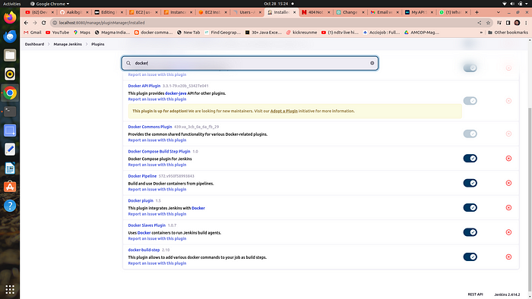

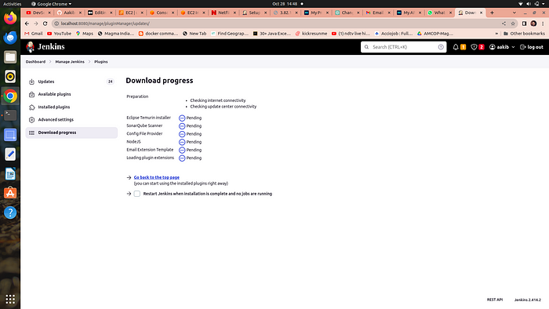

**Step 2 → add credentials of Sonarqube and Docker**

1st we genrate a token for sonarqube to use in jenkins credentials as secret text

**setup sonarqube credentials**

1. go to [http://publicip:9000](http://publicip:9000/)
2. now enter your username and password
3. click on security →users →token →generate token

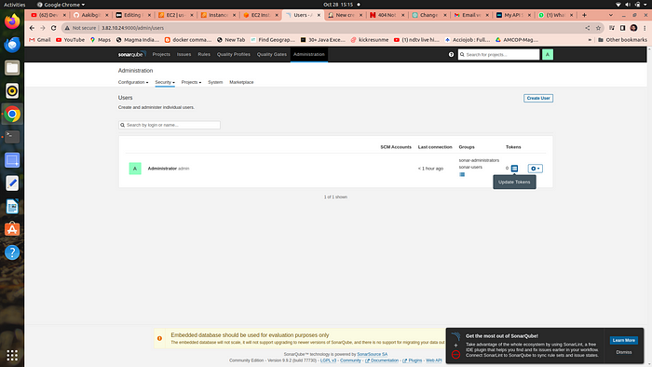

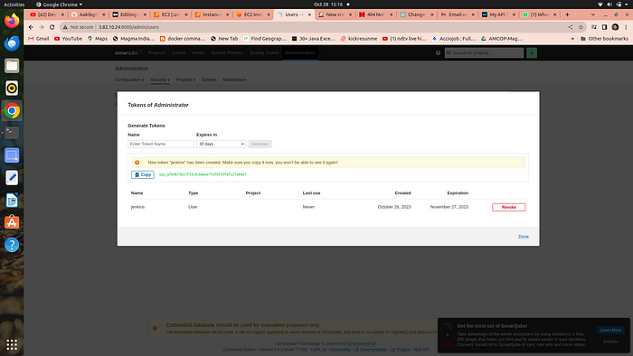

4. copy the token and go to your jenkins →manage jenkins →credentials →global →add credentials

5. select secret text from dropdown

6. secret text ==your token , id =sonar-token →click on create

**setup projects in sonarqube for jenkins**

1. go to your sonarqube server
2. click on projects
3. in the name field type Netflix
4. click on set up

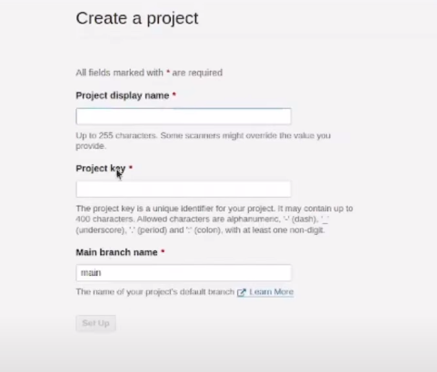

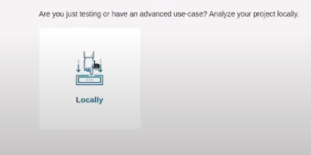

click on this option

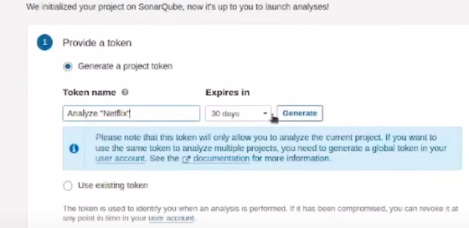

click on generate

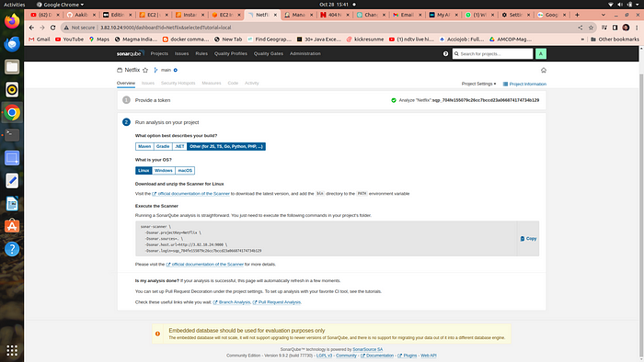

**select the os and the following commands used in jenkins pipeline code that set sonarqube to watch over jenkins**

**Setup docker credentials**

1. go to your jenkins →manage jenkins →credentials →global →add credentials
2. provide your username and password of your dockerhub
3. id==docker

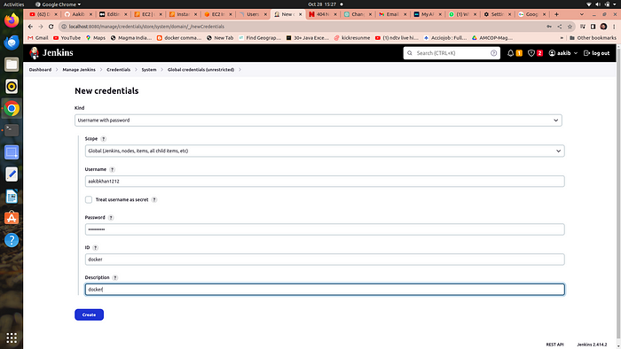

**Step 3→Now we are going to setup tools for jenkins**

**go to manage jenkins → tools**

**a. add jdk**

1. click on add jdk and select installer adoptium.net
2. choose jdk 17.0.8.1+1version and in name section enter jdk 17

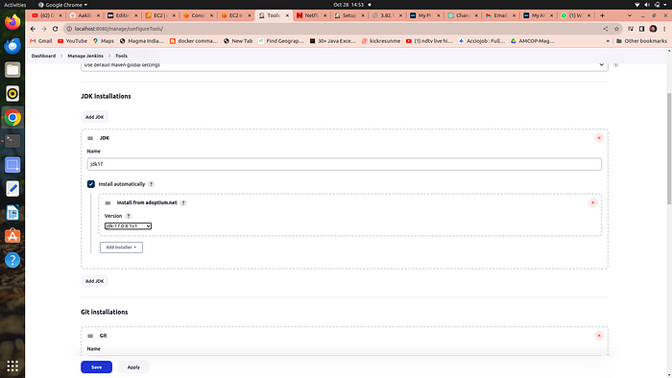

**b. add node js**

1. click on add nodejs
2. enter node16 in name section
3. choose version nodejs 16.2.0

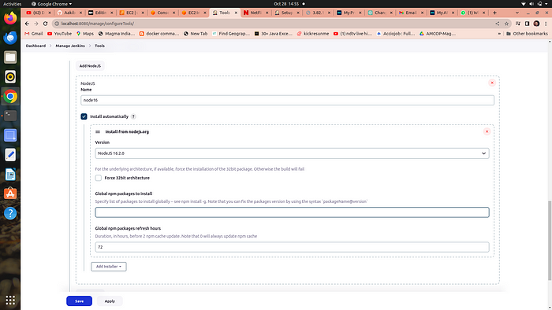

**c. add docker →**

1. click on add docker
2. name==docker
3. add installer ==download from docker.com

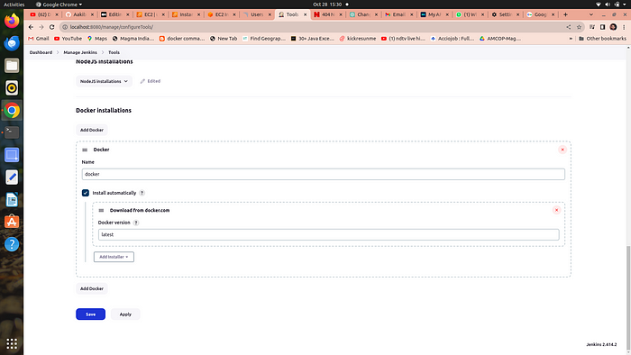

**d. add sonarqube →**

1. add sonar scanner
2. name ==sonar-scanner

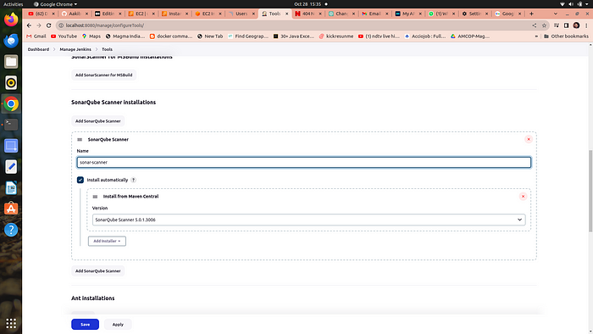

**e. add owasp dependency check →**

Adding the Dependency-Check plugin in the “Tools” section of Jenkins allows you to perform automated security checks on the dependencies used by your application

1. add dependency check
2. name == DP-Check
3. from add installer select install from github.com

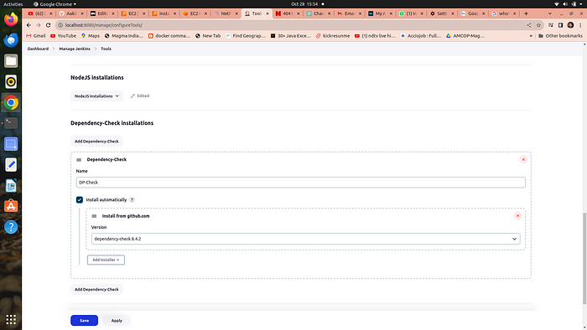

**Step 4 →Configure global setting for sonarube**

1. go to manage jenkins →Configure global setting →add sonarqube servers
2. n**ame ==sonar-server**
3. **server\_url==http://public\_ip:9000**
4. **server authentication token == sonar-token**

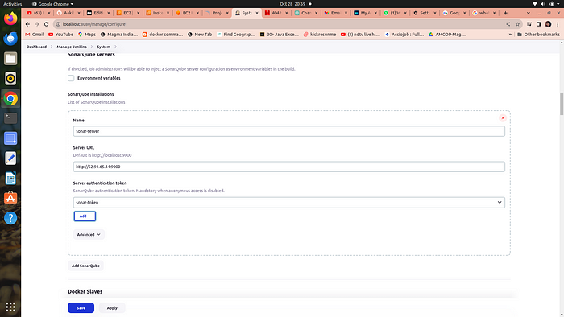

**Step 5 →let’s run the Pipeline →**

1. **go to new item →select pipeline** →in the name section type **netflix**
2. scroll down to the pipeline script and copy paste the following code

pipeline{  
 agent any  
 tools{  
 jdk 'jdk17'  
 nodejs 'node16'  
 }  
 environment {  
 SCANNER\_HOME=tool 'sonar-scanner'  
 }  
 stages {  
 stage('clean workspace'){  
 steps{  
 cleanWs()  
 }  
 }  
 stage('Checkout from Git'){  
 steps{  
 git branch: 'main', url: '[https://github.com/Hussain147/netflix-cicd/'](https://github.com/Hussain147/netflix-cicd/)  
 }  
 }  
 stage("Sonarqube Analysis "){  
 steps{  
 withSonarQubeEnv('sonar-server') {  
 sh ''' $SCANNER\_HOME/bin/sonar-scanner -Dsonar.projectName=Netflix \  
 -Dsonar.projectKey=Netflix '''  
 }  
 }  
 }  
 stage("quality gate"){  
 steps {  
 script {  
 waitForQualityGate abortPipeline: false, credentialsId: 'Sonar-token'   
 }  
 }   
 }  
 stage('Install Dependencies') {  
 steps {  
 sh "npm install"  
 }  
 }  
 stage('OWASP FS SCAN') {  
 steps {  
 dependencyCheck additionalArguments: '--scan ./ --disableYarnAudit --disableNodeAudit', odcInstallation: 'DP-Check'  
 dependencyCheckPublisher pattern: '\*\*/dependency-check-report.xml'  
 }  
 }  
 stage('TRIVY FS SCAN') {  
 steps {  
 sh "trivy fs . > trivyfs.txt"  
 }  
 }  
 stage("Docker Build & Push"){  
 steps{  
 script{  
 withDockerRegistry(credentialsId: 'docker', toolName: 'docker'){   
 sh "docker build --build-arg TMDB\_V3\_API\_KEY=<yourapikey> -t netflix ."  
 sh "docker tag netflix kubehussain/netflix:latest "  
 sh "docker push kubehussain/netflix:latest "  
 }  
 }  
 }  
 }  
 stage("TRIVY"){  
 steps{  
 sh "trivy image nasi101/netflix:latest > trivyimage.txt"   
 }  
 }  
 stage('Deploy to container'){  
 steps{  
 sh 'docker run -d --name netflix -p 8081:80 nasi101/netflix:latest'  
 }  
 }  
 }  
}If you get docker login failed errorrsudo su  
sudo usermod -aG docker jenkins  
sudo systemctl restart jenkins

3. Your Pipeline is started to build the following docker image and send it to dockerhub with all security checks

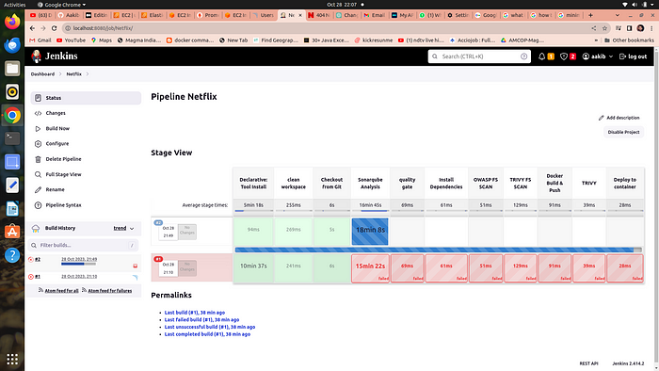

**Phase 4 →Monitering via Prmotheus and grafana**

* **Prometheus**is like a detective that constantly watches your software and gathers data about how it’s performing. It’s good at collecting metrics, like how fast your software is running or how many users are visiting your website.
* **Grafana**, on the other hand, is like a dashboard designer. It takes all the data collected by Prometheus and turns it into easy-to-read charts and graphs. This helps you see how well your software is doing at a glance and spot any problems quickly.

In other words, Prometheus collects the information, and Grafana makes it look pretty and understandable so you can make decisions about your software. They’re often used together to monitor and manage applications and infrastructure.

**Step 1 →Setup another server or EC2 for moniterning**

1. go to ec2 console and launch an instance having a base image ofu buntu and with t2.medium specs because **Minimum Requirements to Install Prometheus :**

* 2 CPU cores.
* 4 GB of memory.
* 20 GB of free disk space.

**Step 2 →Installing Prometheus:**

1. **First, create a dedicated Linux user for Prometheus and download Prometheus:**

**a.**sudo useradd — system — no-create-home — shell /bin/false prometheus

**b.**wget <https://github.com/prometheus/prometheus/releases/download/v2.47.1/prometheus-2.47.1.linux-amd64.tar.gz>

**2. Extract Prometheus files, move them, and create directories:**

**a.**tar -xvf prometheus-2.47.1.linux-amd64.tar.gz

**b.** cd prometheus-2.47.1.linux-amd64/

**c.**sudo mkdir -p /data /etc/prometheus

**d.**sudo mv prometheus promtool /usr/local/bin/

**e.**sudo mv consoles/ console\_libraries/ /etc/prometheus/

**f.**sudo mv prometheus.yml /etc/prometheus/prometheus.yml

**3. Set ownership for directories:**

**a.**sudo chown -R prometheus:prometheus /etc/prometheus/ /data/

**4. Create a systemd unit configuration file for Prometheus:**

**a.** sudo nano /etc/systemd/system/prometheus.service

Add the following code to the prometheus.service file:

[Unit]  
Description=Prometheus  
Wants=network-online.target  
After=network-online.target  
  
StartLimitIntervalSec=500  
StartLimitBurst=5  
  
[Service]  
User=prometheus  
Group=prometheus  
Type=simple  
Restart=on-failure  
RestartSec=5s  
ExecStart=/usr/local/bin/prometheus \  
 --config.file=/etc/prometheus/prometheus.yml \  
 --storage.tsdb.path=/data \  
 --web.console.templates=/etc/prometheus/consoles \  
 --web.console.libraries=/etc/prometheus/console\_libraries \  
 --web.listen-address=0.0.0.0:9090 \  
 --web.enable-lifecycle  
  
[Install]  
WantedBy=multi-user.target

**b.** press →**ctrl+o**#for save and then **ctrl+x** #for exit from the file

Here’s a explanation of the key parts in this above file:

* User and Group specify the Linux user and group under which Prometheus will run.
* ExecStart is where you specify the Prometheus binary path, the location of the configuration file (prometheus.yml), the storage directory, and other settings.
* web.listen-address configures Prometheus to listen on all network interfaces on port 9090.
* web.enable-lifecycle allows for management of Prometheus through API calls.

**5. Enable and start Prometheus:**

**a.**sudo systemctl enable prometheus  
**b.**sudo systemctl start prometheus

**c.** sudo systemctl status prometheus

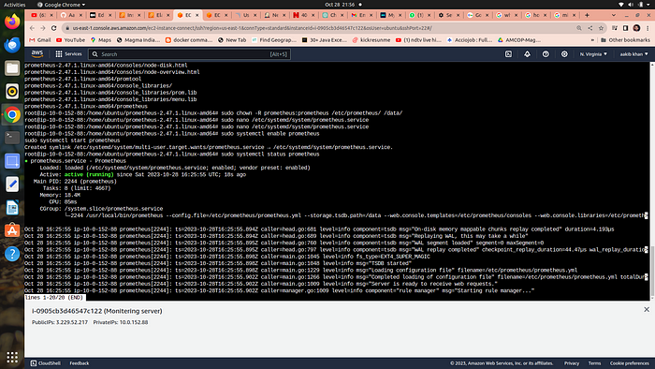

**Now go to your security group of your ec2 to enable port 9090 in which prometheus will run**

go to → [http://public\_ip:9090](http://public_ip:9090/) to see the webpage of prometheus

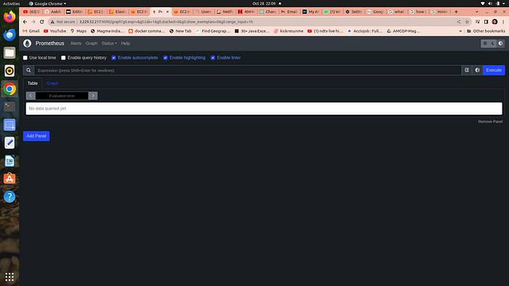

**Step 3 → Installing Node Exporter:**

Node exporter is like a “reporter” tool for Prometheus, which helps collect and provide information about a computer (node) so Prometheus can monitor it. It gathers data about things like CPU usage, memory, disk space, and network activity on that computer.

A Node Port Exporter is a specific kind of Node Exporter that is used to collect information about network ports on a computer. It tells Prometheus which network ports are open and what kind of data is going in and out of those ports. This information is useful for monitoring network-related activities and can help you ensure that your applications and services are running smoothly and securely.

Run the following commands for installation

1. **Create a system user for Node Exporter and download Node Exporter:**

**a.**sudo useradd — system — no-create-home — shell /bin/false node\_exporter

**b .** wget <https://github.com/prometheus/node_exporter/releases/download/v1.6.1/node_exporter-1.6.1.linux-amd64.tar.gz>

**2. Extract Node Exporter files, move the binary, and clean up:**

**a.** tar -xvf node\_exporter-1.6.1.linux-amd64.tar.gz  
**b.** sudo mv node\_exporter-1.6.1.linux-amd64/node\_exporter /usr/local/bin/  
**c.** rm -rf node\_exporter\*

**3. Create a systemd unit configuration file for Node Exporter:**

**a.** sudo nano /etc/systemd/system/node\_exporter.service

add the following code to the node\_exporter.service file:

provide more detailed information about what might be going wrong. For example:

[Unit]  
Description=Node Exporter  
Wants=network-online.target  
After=network-online.target  
  
StartLimitIntervalSec=500  
StartLimitBurst=5  
  
[Service]  
User=node\_exporter  
Group=node\_exporter  
Type=simple  
Restart=on-failure  
RestartSec=5s  
ExecStart=/usr/local/bin/node\_exporter --collector.logind  
  
[Install]  
WantedBy=multi-user.targetb. press → ctrl+o then ctrl+x

**4. Enable and start Node Exporter:**

**a.**sudo systemctl enable node\_exporter  
**b.**sudo systemctl start node\_exporter

**c.**sudo systemctl status node\_exporter

**node exporter service is now running**

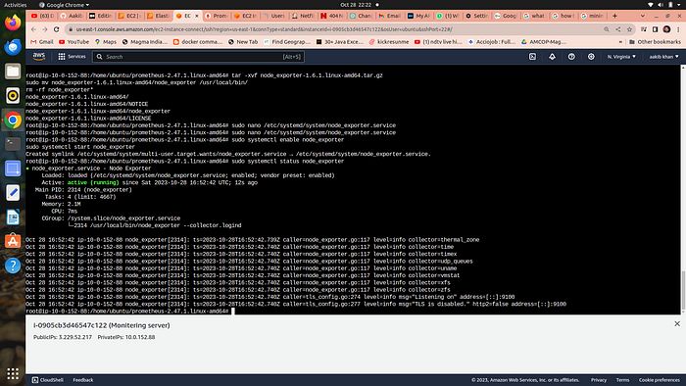

You can access Node Exporter metrics in Prometheus.

**Step 4→Configure Prometheus Plugin Integration:**

1. go to your EC2 and run →**cd /etc/prometheus**

2. you have to edit the prometheus.yml file to moniter anything

global:  
 scrape\_interval: 15s  
  
scrape\_configs:  
 - job\_name: 'node\_exporter'  
 static\_configs:  
 - targets: ['localhost:9100']  
  
 - job\_name: 'jenkins'  
 metrics\_path: '/prometheus'  
 static\_configs:  
 - targets: ['<your-jenkins-ip>:<your-jenkins-port>']

**add the above code with proper indentation like this →**

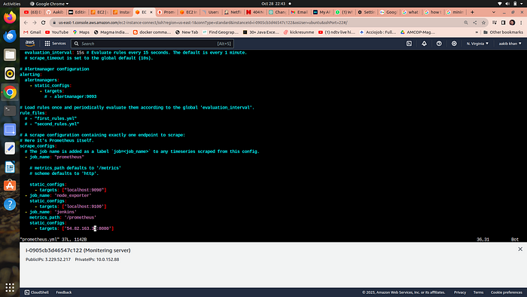

press esc+:wq to save and exit

**a.**Check the validity of the configuration file →

**promtool check config /etc/prometheus/prometheus.yml**

***o/p →success***

**b.** Reload the Prometheus configuration without restarting →

**curl -X POST**[**http://localhost:9090/-/reload**](http://localhost:9090/-/reload)

**go to your prometheus tab again and click on status and select targets you will there is three targets present as we enter in yaml file for moniterning**

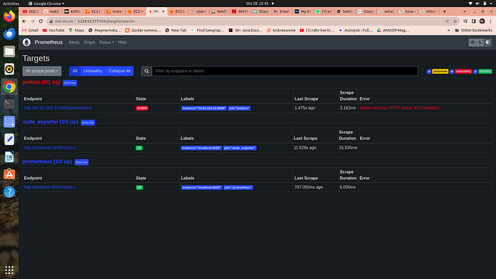

prometheus targets dashboard

**Step 5 →Setup Grafana →**

**Install Dependencies:**

**a.** sudo apt-get update  
**b.**sudo apt-get install -y apt-transport-https software-properties-common

**Add the GPG Key for Grafana:**

**a.**wget -q -O — <https://packages.grafana.com/gpg.key> | sudo apt-key add -

**Add the repository for Grafana stable releases:**

**a.**echo “deb <https://packages.grafana.com/oss/deb> stable main” | sudo tee — a /etc/apt/sources.list.d/grafana.list

**Update the package list , install and start Grafana:**

**a.**sudo apt-get update  
**b.**sudo apt-get -y install grafana

**c.** sudo systemctl enable grafana-server

**d.** sudo systemctl start grafana-server

**e.** sudo systemctl status grafana-server

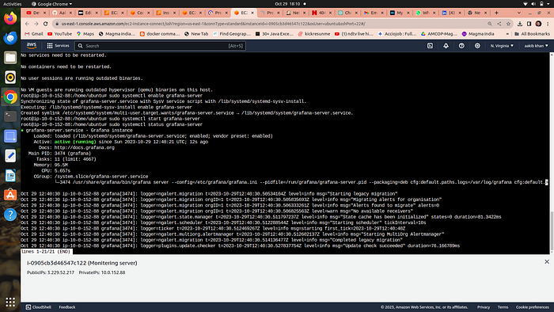

**Now go to your ec2 security group and open port no. 3000 in which grafana runs**

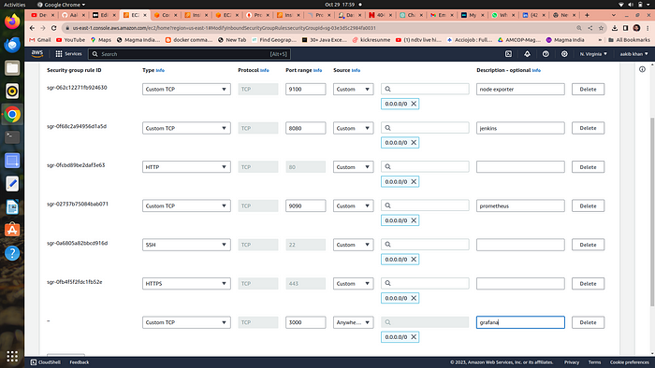

Go and browse [http://public\_ip:3000](http://public_ip:3000/) to access your grafana web interface

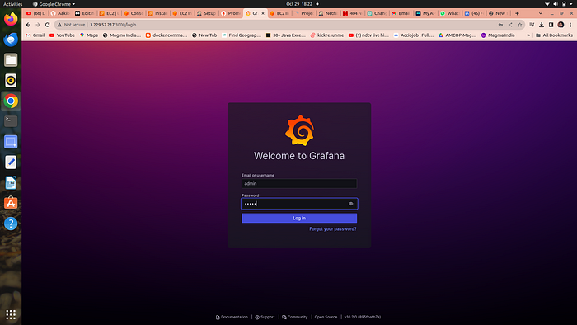

username = admin, password =admin

**Step 6 →Add Prometheus Data Source:**

To visualize metrics, you need to add a data source.

**Follow these steps:**

* Click on the gear icon (⚙️) in the left sidebar to open the “Configuration” menu.
* Select “Data Sources.”
* Click on the “Add data source” button.

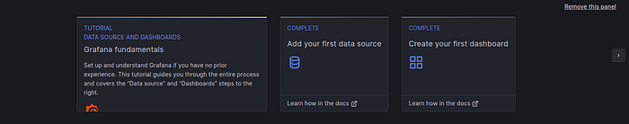

* Choose “Prometheus” as the data source type.
* In the “HTTP” section:
* Set the “URL” to http://localhost:9090 (assuming Prometheus is running on the same server).
* Click the “Save & Test” button to ensure the data source is working.

**Step 7 → Import a Dashboard**

Importing a dashboard in Grafana is like using a ready-made template to quickly create a set of charts and graphs for monitoring your data, without having to build them from scratch.

* Click on the “+” (plus) icon in the left sidebar to open the “Create” menu.

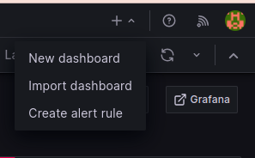

* Select “Dashboard.”
* Click on the “Import” dashboard option.
* Enter the dashboard code you want to import (e.g., code 1860).
* Click the “Load” button.

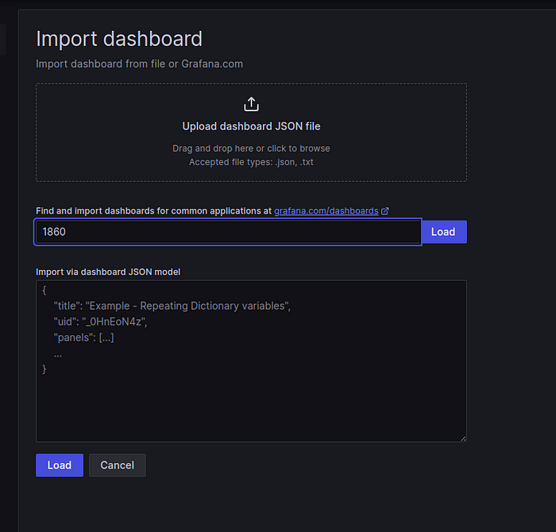

* Select the data source you added (Prometheus) from the dropdown.
* Click on the “Import” button.

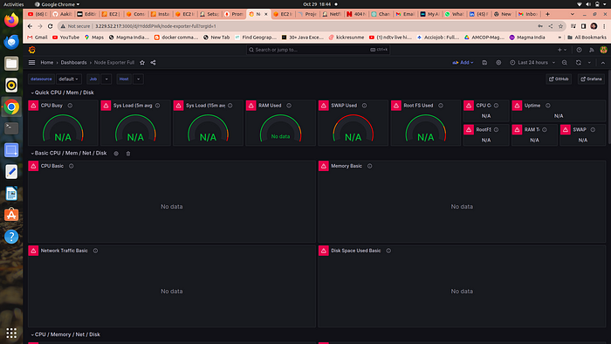

**Step 7 →Configure global setting for promotheus**

go to manage jenkins →system →search for promotheus — apply →save

**Step 8→ import a dashboard for jenkins**

* Click on the “+” (plus) icon in the left sidebar to open the “Create” menu.
* Select “Dashboard.”
* Click on the “Import” dashboard option.
* Enter the dashboard code you want to import (e.g., code 9964).
* Click the “Load” button.
* Select the data source you added (Prometheus) from the dropdown.

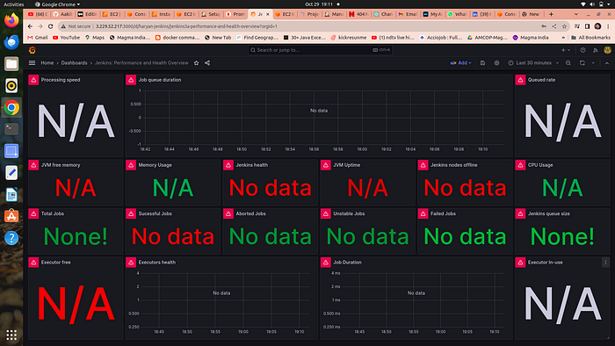

[**Phase 5: Kubernetes**](https://github.com/Aakibgithuber/Deploy-Netflix-Clone-on-Kubernetes#phase-6-kubernetes)**→**

**Step 1 →Setup EKS(Elastic Kubernetes Service) on aws**

1. go to console and search for EKS
2. click on add a cluster

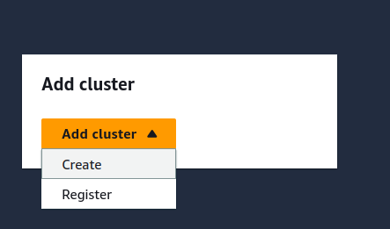

click on create

3. add a name to your cluster and choose a service role if you don’t have then follow below documentation to create it

**[Amazon EKS cluster IAM role](https://docs.aws.amazon.com/eks/latest/userguide/service_IAM_role.html?source=post_page-----9ae6091b88bd--------------------------------" \t "_blank)**

[The Amazon EKS cluster IAM role is required for each cluster. Kubernetes clusters managed by Amazon EKS use this role…](https://docs.aws.amazon.com/eks/latest/userguide/service_IAM_role.html?source=post_page-----9ae6091b88bd--------------------------------" \t "_blank)

[docs.aws.amazon.com](https://docs.aws.amazon.com/eks/latest/userguide/service_IAM_role.html?source=post_page-----9ae6091b88bd--------------------------------" \t "_blank)

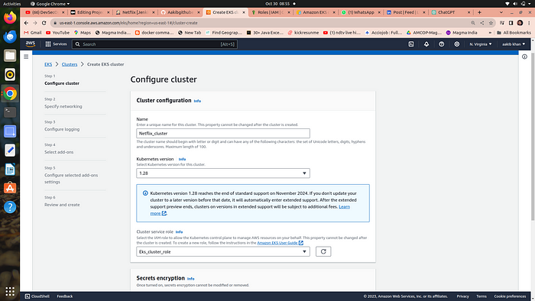

4. click on next and choose the default vpc and in subnet option make sure to remove all the private subnet and remain everything as it is

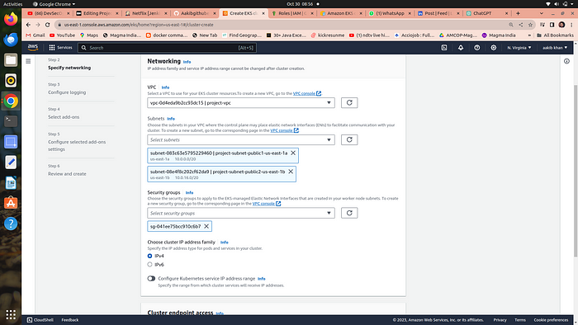

5. click on next →next →create

6. when you cluster is ready then **go to compute option and add a node group**

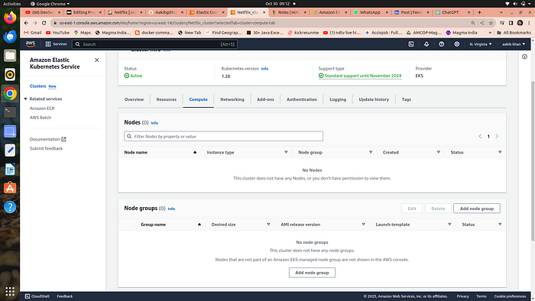

7. choose the below options

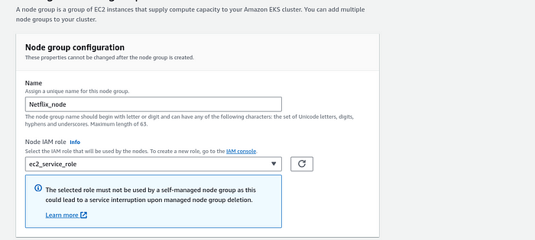

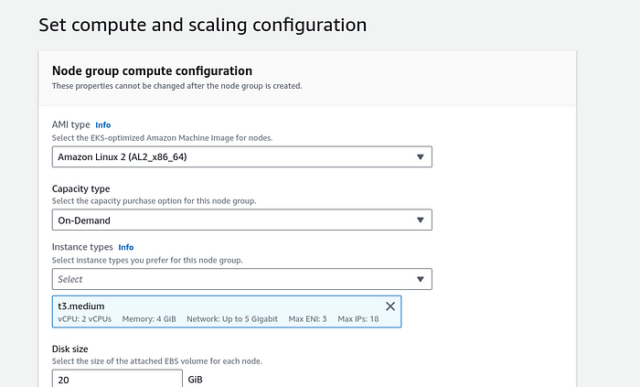

**Remain everything as it is →click on create**

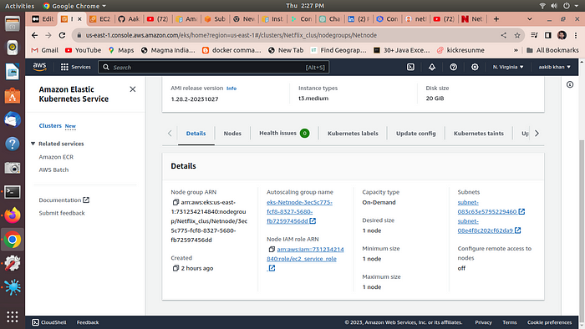

**Step 2 →Installing aws -cli to control the cluster from our terminal**

Now go to your terminal and run

1. **pip install awscli**
2. **aws configure**
3. **enter a access key and then secret access key**

**How to create access key**

1. **go to your console click on your username and then select Security Credentials option**

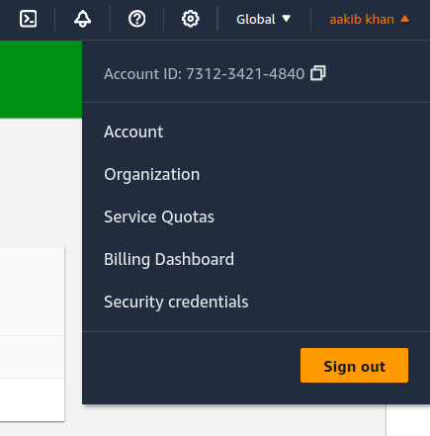

**2. scroll down to access keys and click on create**

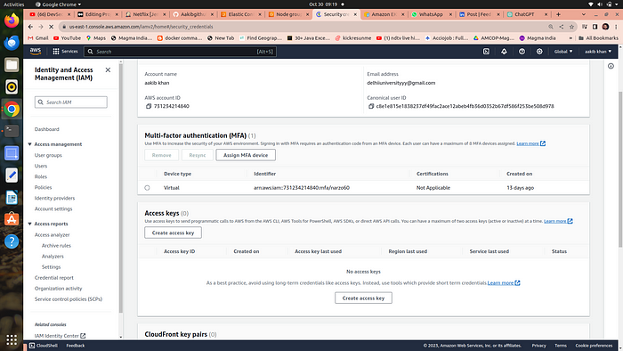

copy and paste it to terminal

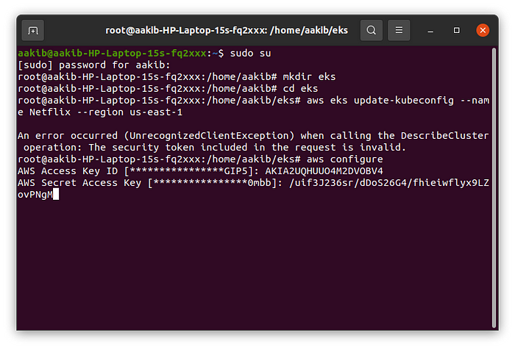

**Run the follwing command**

1. **aws eks update-kubeconfig — name YourClusterName — region us-east-1**

This command is used to update the Kubernetes configuration (kubeconfig) file for an Amazon Elastic Kubernetes Service (EKS) cluster named "Netflix\_cluster" in the "us-east-" region, allowing you to interact with the cluster using kubectl.

**Step 3→Install helm →**

1. curl <https://baltocdn.com/helm/signing.asc> | gpg — dearmor | sudo tee /usr/share/keyrings/helm.gpg > /dev/null
2. sudo apt-get install apt-transport-https — yes
3. echo “deb [arch=$(dpkg — print-architecture) signed-by=/usr/share/keyrings/helm.gpg] <https://baltocdn.com/helm/stable/debian/> all main” | sudo tee /etc/apt/sources.list.d/helm-stable-debian.list
4. sudo apt-get install helm

**Step →4 Install Node Exporter using Helm**

To begin monitoring your Kubernetes cluster, you’ll install the Prometheus Node Exporter by Using Helm to install Node Exporter in Kubernetes makes it easy to set up and manage the tool for monitoring your servers by providing a pre-packaged, customizable, and consistent way to do it.

1. Add the Prometheus Community Helm repository:

* helm repo add prometheus-community <https://prometheus-community.github.io/helm-charts>

1. Create a Kubernetes namespace for the Node Exporter:

* kubectl create namespace prometheus-node-exporter

1. Install the Node Exporter using Helm:

* helm install prometheus-node-exporter prometheus-community/prometheus-node-exporter — namespace prometheus-node-exporter

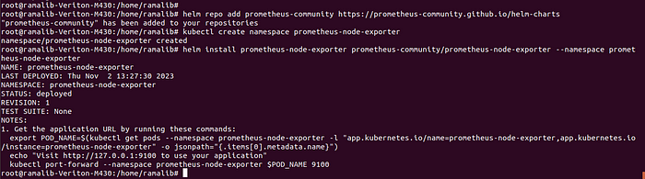

1. kubectl get pods -n prometheus-node-exporter → run this to verify



**Add a Job to Scrape Metrics on nodeip:9001/metrics in prometheus.yml:**

Update your Prometheus configuration (prometheus.yml) to add a new job for scraping metrics from nodeip:9001/metrics. You can do this by adding the following configuration to your prometheus.yml file:

- job\_name: 'Netflix'  
 metrics\_path: '/metrics'  
 static\_configs:  
 - targets: ['node1Ip:9100']

Replace ‘your-job-name’ with a descriptive name for your job. The static\_configs section specifies the targets to scrape metrics from, and in this case, it’s set to nodeip:9001.

Don’t forget to reload or restart Prometheus to apply these changes to your configuratiDeploy Application with ArgoCDon.

**Step 5→Install Argo cd**

Argo CD is a tool that helps software developers and teams manage and deploy their applications to Kubernetes clusters more easily. It simplifies the process of keeping your applications up to date and in sync with your desired configuration by automatically syncing your code with what’s running in your Kubernetes environment. It’s like a traffic cop for your chmod 700 get\_helm.shapplications on Kubernetes, ensuring they are always in the right state without you having to manually make changes.

1. Add the Argo CD Helm repository:

* helm repo add argo-cd <https://argoproj.github.io/argo-helm>

2. Update your Helm repositories:

* helm repo update

3. Create a namespace for Argo CD (optional but recommended):

* kubectl create namespace argocd

4. Install Argo CD using Helm:

* helm install argocd argo-cd/argo-cd -n argocd

5. kubectl get all -n argocd

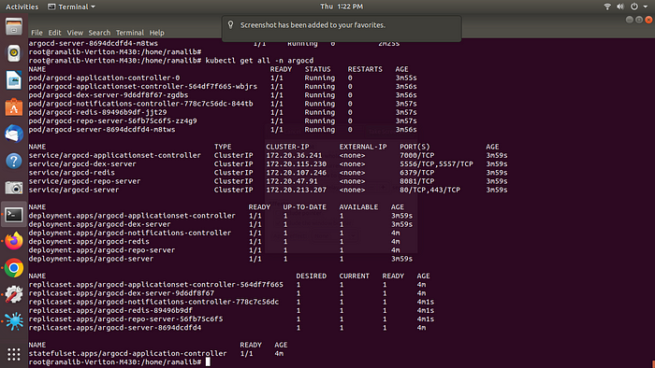

**Expose argocd-server**

**By default argocd-server is not publicaly exposed.** For the purpose of this workshop, we will use a Load Balancer to make it usable:

1. kubectl patch svc argocd-server -n argocd -p '{"spec": {"type": "LoadBalancer"}}'
2. export ARGOCD\_SERVER=`kubectl get svc argocd-server -n argocd -o json | jq — raw-output ‘.status.loadBalancer.ingress[0].hostname’`
3. **echo $ARGOCD\_SERVER**



**you have given a url copy and paste it on your chrome browser**

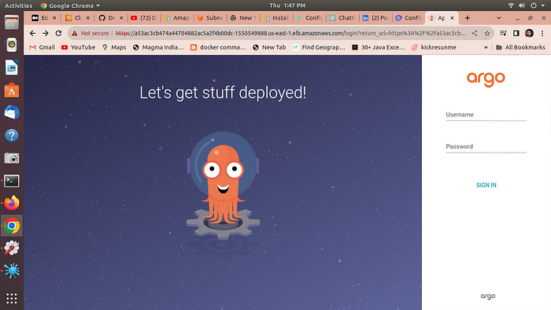

username ==admin

**For Password →**

1. export ARGO\_PWD=`kubectl -n argocd get secret argocd-initial-admin-secret -o jsonpath=”{.data.password}” | base64 -d`
2. echo $ARGO\_PWD
3. output == password for argocd

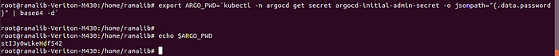

copy and paste the password on argocd page and you are logged in

**Step 5 →**[**Deploy Application with ArgoCD**](https://github.com/Aakibgithuber/Deploy-Netflix-Clone-on-Kubernetes/blob/main/README.md#deploy-application-with-argocd)

Sign into argo cd using above steps →

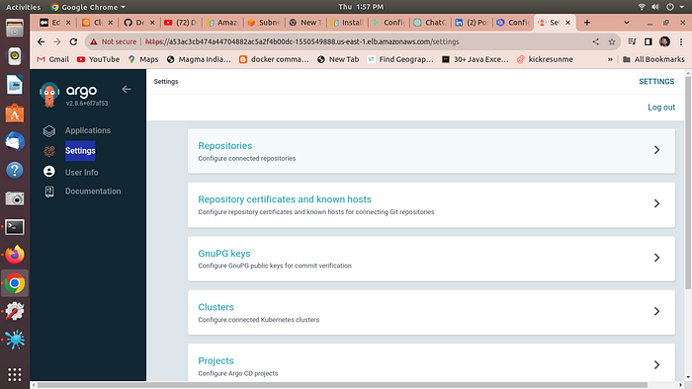

1. **go to setting →repositories →connect repo**

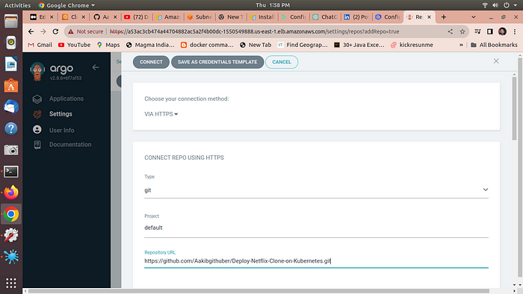

select these options and on repo url copy n paste your github url

**2. click on connect output →successful**

**3. Now go to application →newapp**

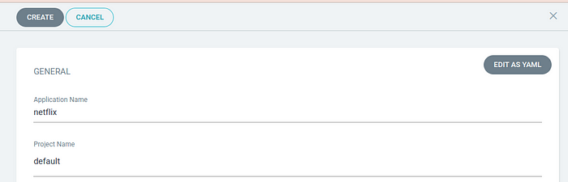

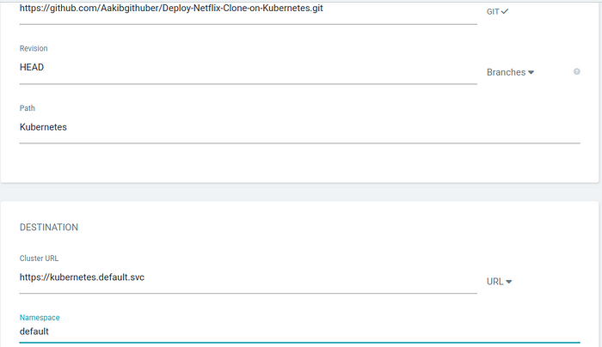

**4. select the above options and click on create**

**5. Now click on sync →force →sync →ok**

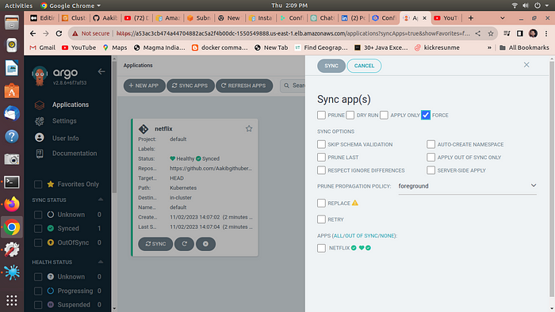

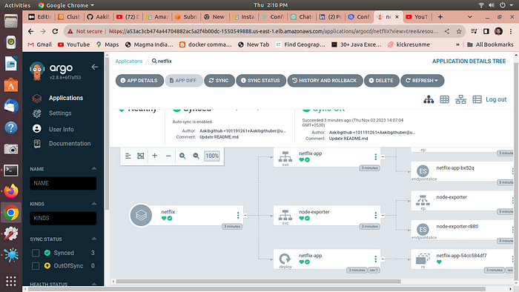

click on netflix app

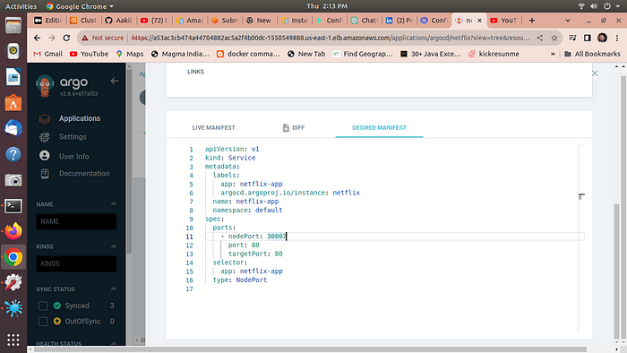

6.**go to your cluster and select the node created by node group and expose port 30007**

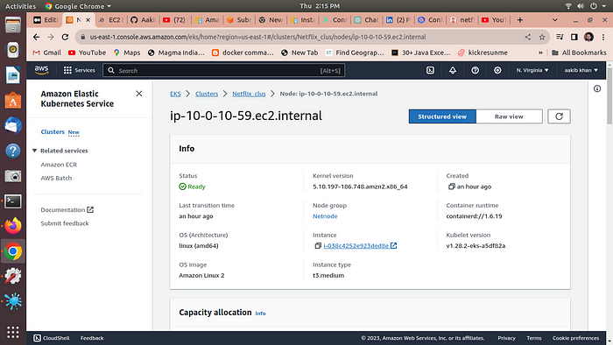

now browse the aplication by Publicip:30007

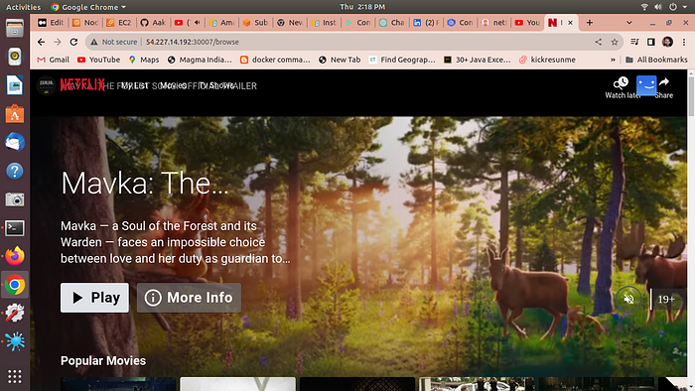

Here is your application is running on port 30007 by EKS

***Congrats Here we completed our project go and add this on your resume***